**ARTICLES: Mentoring Recommended Readings -- Best Practices**

*Revised December 27, 2023.* - [jpgomez@ollusa.edu](mailto:jpgomez@ollusa.edu)

TITLE: **Online Guide to the Science of Effective Mentoring in STEMM**

Author: National Academies of Sciences, Engineering, and Medicine

Published: 2019

Topic: Mentorship is essential in developing science, technology, engineering, mathematics, and medicine (STEMM) professionals. It is a set of skills that can and should be learned, practiced, and improved upon with self-reflection and feedback. If you are a mentor or mentee yourself, or if you are a leader in your organization responsible for ensuring that your faculty and their mentees have the skills to engage in the most effective mentoring relationships, this guide is for you.

LINK: <https://www.nap.edu/resource/25568/interactive/>

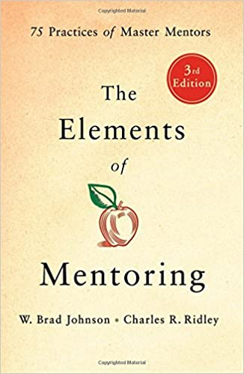

TITLE: **The Elements of Mentoring: 75 Practices of Master Mentors, 3rd Edition.**

Author: W. Brad Johnson & Charles R. Ridley

Published: June 19, 2018

Topic: Patterned after Strunk and White's classic *The Elements of Style*, this third edition concisely summarizes the substantial existing research on the art and science of mentoring. W. Brad Johnson's and Charles R. Ridley's classic guide, *The Elements of Mentoring*, reduces this wealth of published material on the topic to the seventy-five most important and pithy truths for mentors in all fields. Here are the 75 practices of master mentors. These include

* what excellent mentors do,
* what makes an excellent mentor,
* how to set up a successful mentor-mentee relationship,
* how to work through problems that develop between mentoring pairs,
* how to mentor with cultural humility and in diverse mentorships,
* what it means to mentor with integrity, and
* how to end the relationship when it has run its course.

Succinct and comprehensive, this is a must-have for any mentor or mentor-to-be.

LINK: <https://www.amazon.com/Elements-Mentoring-Practices-Master-Mentors/dp/1250181267/ref=sr_1_1?dchild=1&keywords=book+elements+of+mentoring+johnson&qid=1605725861&sr=8-1>

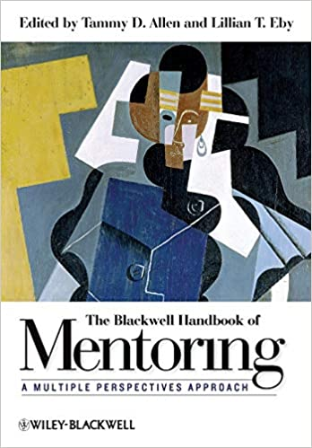

TITLE: **The Blackwell Handbook of Mentoring: A Multiple Perspectives Approach (1st ed)**

Author: Tammy D. Allen & Lillian T. Eby (Editors)

Published: April 26, 2010. Wiley-Blackwell

Topic: Cutting across the fields of psychology, management, education, counseling, social work, and sociology, *The Blackwell Handbook of Mentoring* reveals an innovative, multi-disciplinary approach to the practice and theory of mentoring.

* Provides a complete, multi-disciplinary look at the practice and theory of mentoring and demonstrates its advantages
* Brings together, for the first time, expert researchers from the three primary areas of mentoring: workplace, academy, and community
* Leading scholars provide critical analysis on important literature concerning theoretical approaches and methodological issues in the field
* Final section presents an integrated perspective on mentoring relationships and projects a future agenda for the field

LINK: <https://www.amazon.com/dp/144433543X/ref=cm_sw_r_em_apa_AJe.Bb2TZ4TC6>