ARTICLES: Teaching and Pedagogy – Recommended Books
Revised March 26, 2025. - jpgomez@ollusa.edu

Article TITLE: My Top 6 Books on Pedagogy
Authors: Zachary Nowak
Published: February 26, 2019
Topic: Zachary Nowak, a new instructor, gives his recommendations.
LINK: http://www.insidehighered.com/advice/2019/02/26/new-instructor-recommends-six-books-pedagogy-and-teaching-opinion?utm_source=Inside+Higher+Ed&utm_campaign=05af0dfa51-WNU_COPY_01&utm_medium=email&utm_term=0_1fcbc04421-05af0dfa51-197800013&mc_cid=05af0dfa51&mc_eid=dbdcee20ba

Book TITLE: Reach Everyone, Teach Everyone: Universal Design for Learning in Higher Education
Authors: Thomas J. Tobin and Kirsten T. Behling
Published: October 2018
Topic: Aimed at faculty members, faculty-service staff, disability support providers, student-service staff, campus leaders, and graduate students who want to strengthen the engagement, interaction, and performance of all college students. It includes resources for readers who want to become UDL experts and advocates: real-world case studies, active-learning techniques, Universal Design for Learning skills, micro- and macro-level UDL-adoption guidance, and use-them-now resources.
LINK: https://wvupressonline.com/node/757?elqTrackId=81c284d0dd1c46049c74fc2135b531d1&elq=b5300e8b548f4c5794ca31a94384bdcb&elqaid=21521&elqat=1&elqCampaignId=10317

Book TITLE: Creating the Path to Success in the Classroom: Teaching to Close the Graduation Gap for Minority, First-Generation, and Academically Unprepared Students
Authors: Kathleen F. Gabriel
Published: 2018
Topic: She covers topics such as creating a positive and inclusive course climate, fostering a community of learners, increasing engagement and students’ interactions, activating connections with culturally relevant material, reinforcing self-efficacy with growth mindset and mental toughness techniques, improving lectures by building in meaningful educational activities, designing reading and writing assignments for stimulating deep learning and critical thinking, and making grade and assessment choices that can promote learning.

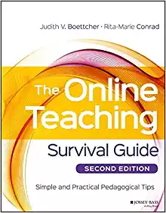 | Book TITLE: The online teaching survival guide: Simple and practical pedagogical tips, 2nd edition.  Authors: Boettcher, J. & Conrad, R.  Published: 2016  Link: https://www.amazon.com/Online-Teaching-Survival-Guide-Pedagogical/dp/1119147689/ref=sr_1_1?s=books&ie=UTF8&qid=1503601190&sr=1-1&keywords=boettcher

Article TITLE: Top 10 Books on Teaching
Author: James M. Lang
Published: June 11, 2014
Topic: Spend some time this summer with at least one book about improving your college classroom.
LINK: https://www.chronicle.com/article/Top-10-Books-on-Teaching/147015

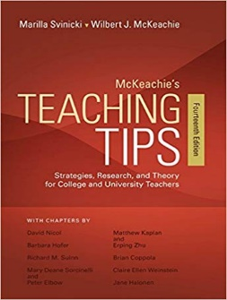 | Book TITLE: McKeachie’s teaching tips: Strategies, research, and theory for college and university instructors, 14th edition.  Authors: McKeachie, W. & Svinicki, M.  Published: 2013  LINK: https://www.amazon.com/McKeachies-Teaching-Tips-Wilbert-McKeachie/dp/1133936792/ref=sr_1_1?s=books&ie=UTF8&qid=1503598596&sr=1-1&keywords=teaching+tips

